# College Heights Secondary

# Math 8

The BIG IDEAS!

|  |  |  |  |  |  |  |  |  |
| --- | --- | --- | --- | --- | --- | --- | --- | --- |
| [Number](https://curriculum.gov.bc.ca/curriculum/mathematics/8/core)  represents, describes, and compares the quantities of ratios, rates, and percents. |  | Computational  [fluency](https://curriculum.gov.bc.ca/curriculum/mathematics/8/core) and flexibility extend to operations with fractions. |  | [Discrete linear relationships](https://curriculum.gov.bc.ca/curriculum/mathematics/8/core) can be represented in many connected ways and used to identify and make generalizations. |  | The relationship between surface area and volume of [3D objects](https://curriculum.gov.bc.ca/curriculum/mathematics/8/core) can be used to describe, measure, and compare spatial relationships. |  | Analyzing [data](https://curriculum.gov.bc.ca/curriculum/mathematics/8/core) by determining averages is one way to make sense of large data sets and enables us to compare and interpret. |

# Topics –

Unit 0: Integers Review Unit 5: Solving Linear Equations

Unit 1: Fractions Unit 6: Linear Relations

Unit 2: Ratios, Rates, & Proportional Reasoning Unit 7: Pythagoras

Unit 3: Percents Unit 8: Surface Area & Volume

Unit 4: Probability and Statistics



**Classroom and Course Expectations**

1. Attendance is MANDATORY (unless sick, of course!) Students are responsible for all assignments and tests missed when absent. Students can access my website to know what material was covered during class. Unit calendars are filled in note packages are posted regularly.

Lharrop.wixsite.com/website

2. Arriving to class on time and ready to learn (with all materials) is expected.

3. Bring all required materials to class. DO NOT count on the teacher to provide you with the basic materials you need to be successful. Materials will need to be replenished throughout the semester.

4. Cell phones can be very distracting in the classroom to the user and to others around the user. They should be left in the students’ bag during class. If phones are used in class, they will likely be taken and returned at the teacher’s discretion (generally to the office after school).

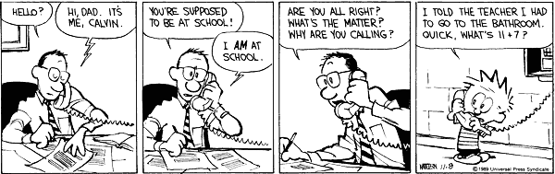

5. Washroom, water or other needs should be looked after during breaks. If you do need to leave the room during class time, you may only do so during quiet work time (and not within the first or last 10 minutes of class).

6. Be courteous and attentive during class time, particularly during question and answer periods. Be considerate of others, and raise your hand if you want to comment.

7. **Falling behind in the assignments** and **missing class** are the greatest hazards in this course.

In high school, we do not have a supply list that is provided to the parents and expected to be brought to school and given to the teacher. It is the responsibility of the student to bring following supplies to class on a **daily** basis.

1. 2 inch 3 ringed binder (Math only) containing:
   1. dividers
   2. lined paper
   3. graph paper (1:4 or quarter inch) (~20 pieces is plenty)
2. pencil case containing:
   1. at least 2 **sharpened** pencils
   2. pen
   3. **dry erase pen** (fine tipped) (I will provide mini white boards)
   4. eraser
   5. ruler
   6. scientific calculator
   7. textbook (school will provide this)

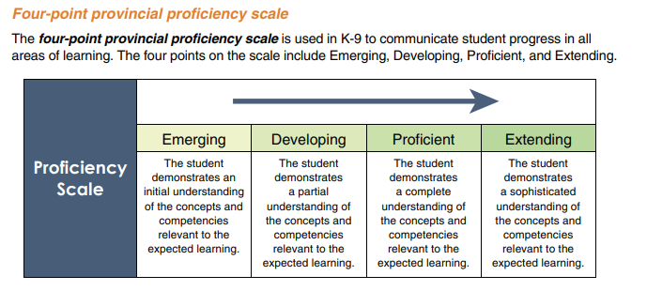

Dear Parent/Guardian,

Regular attendance and punctuality are necessary for your child to be successful in Math 8. Please encourage your child complete all assignments on a nightly basis and do regular review in order for him/her to be prepared for quizzes and unit tests.

I will hand out mark updates after each unit test. I will also send home an electronic version of the mark update after each test. These mark updates will include assignment completion as well as quiz and test results. Please provide your email address below, or you can email me to ensure I have the correct address. If you do not receive any emails by late September, please contact me.

Students can access missed notes and unit calendars on my website, **Lharrop.wixsite.com/website**, at any time.

If you have any questions, comments or concerns, please feel free to e-mail me at [Lharrop@sd57.bc.ca](mailto:Lharrop@sd57.bc.ca) or call me at 964-4431 ext. 254.

Thank you.

Mrs. Harrop

Dear Parent/Guardian,

Regular attendance and punctuality are necessary for your child to be successful in Math 8. Please encourage your child complete all assignments and do regular review in order for him/her to be prepared for quizzes and unit tests.

I will hand out mark updates after each unit test. I will also send home an electronic version of the mark update after each test. These mark updates will include assignment completion as well as quiz and test results. Please provide your email address below, or you can email me to ensure I have the correct email address. If you do not receive any emails by mid September, please contact me.

Students can access missed notes and unit calendars on my website, **Lharrop.wixsite.com/website**, at any time.

If you have any questions, comments or concerns, please feel free to e-mail me at [Lharrop@sd57.bc.ca](mailto:Lharrop@sd57.bc.ca) or call me at 964-4431 ext. 254.

Please sign below indicating that you have read through the above course outline/guidelines for Math 8.

Thank you.

Mrs. Harrop

___________________________________ _______________________________

Student Name Student Signature

___________________________________ _______________________________

Parent/Guardian Name and **email address** Parent/Guardian Signature

Preferred contact:

Name: _________________________ Relationship to student: _________________________

Preferred form of communication (circle one) e-mail phone (provide number)

**Teacher Copy**. Please sign and return as soon as possible.

Please fill out below to the best of your ability.

What elementary school did you attend? ___________________________________________

What high school experience are you most excited for? ________________________________

______________________________________________________________________________

What is your favourite part of math? _______________________________________________

_____________________________________________________________________________

What is your least favourite part of math? __________________________________________

_____________________________________________________________________________

What are your expectations for yourself in this course? (ie. mark, homework completion, quiz results)

______________________________________________________________________________

______________________________________________________________________________

______________________________________________________________________________

Do you have a strategy to receive help out of class time? If so, what is that strategy?

______________________________________________________________________________

______________________________________________________________________________

______________________________________________________________________________

Do you have anything that you would like to share?

______________________________________________________________________________

______________________________________________________________________________

______________________________________________________________________________